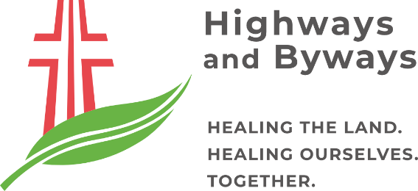
2023 SMALL GRANTS PROGRAM
APPLICATION FORM
Healing and Growing Together

To apply for a grant please complete all questions.

Applicant
Name of organisation undertaking the project:
Name of organisation who would receive and manage the funding (if different to above):
Contact person:
Postal address: | Street or PO Box number:
 | Suburb/Town:
 | State: |  |  | Postcode:
Email address:
Telephone contact:
Organisation website:
Name of partner organisations (if any):
Project Information
Project name:
Proposed commencement date: |  |  | Proposed completion date:
Amount requested: |  |  | Total project cost:
Provide a brief project description:
Provide a short summary of the project in several sentences or dot points.
Where is your project located?
Please insert the name of location/s.
In which Indigenous Country/region will your project occur?
Regions are denoted in the map of Indigenous Australia at https://aiatsis.gov.au/explore/map-indigenous-australia.
Why is there a need for your project?
How does your project achieve the program theme of ‘Healing and Growing Together’?
How does your project:
- address social and ecological disadvantage and/or inequality?
- support communities to heal and grow in response to the environmental challenges of the last few years? and/or
- support communities as they reconnect and recover from the social impacts of Covid19?
Outline the project timelines and stages:

What are the expected outcomes?
What changes do you hope to see happen in your community?
How did you hear about the Highways and Byways Small Grants Program?  Please tick |  | ☐ Website  ☐ Email  ☐ Newsletters  ☐ Parish networks  ☐ Local government networks  ☐ Environmental network  ☐ Community network  ☐ Facebook  ☐ Instagram  ☐ Twitter  ☐ LinkedIn  ☐ Previous grant applicant or recipient  ☐ Other Please specify:
Project Budget
Please complete the budget proposal below.
(Note: the project budget must balance; i.e. Total Income = Total Expenditure).
INCOME | $ | Comments/Details
Amount requested from Highways and Byways
Any other source of income:
In-kind contributions:
Estimated value for non-cash contributions such as services, equipment, time and material
Total Income
EXPENDITURE
Items: (Breakdown of individual items such as salaries, equipment, travel/transport, administration)
In-kind contributions: (As above)
Total Expenditure
Declaration

- I am authorised to submit this application on behalf of the applicant.
- The information contained within this application is true and correct.
- I understand that if this application for funding is successful, the applicant will be required to complete a funding agreement with Highways and Byways Ltd.

Please date and sign as following. Electronic signatures are permissible.

Name of key contact person:
Phone number:
Date:

Signature
Submission:
Please return one copy of this proposal by 5pm AEDT Wednesday 15 March 2023 to:

Highways and Byways
Grants Administration

By post:
90 Albion Road
Box Hill, VIC, 3128

Or by email:
grants@hb.org.au

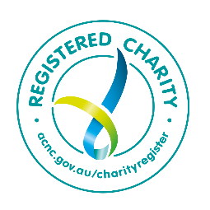
HIGHWAYS AND BYWAYS – HEALING THE LAND, HEALING OURSELVES, TOGETHER
90 Albion Road, Box Hill, VIC, 3128
Phone: 03 9087 8606
www.hb.org.au
Email: grants@hb.org.au
ABN 75 691 644 631

